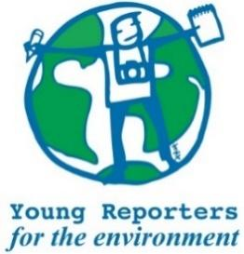

**YRE International Competition**

**Competition entry form 2025/2026**

**Category: Staged Campaign Photo**

*Questions marked with * must be answered.*

|  |  |
| --- | --- |
| **Name of student(s)\*** |  |
| **Age(s) of students as of National Competition deadline (24/4/2026)\*** |  |
| **Name of school\*** |  |
| **Title of the submission (within 140 characters)\*** |  |
| **Town and Postcode of school\*** |  |
|  |  |
| **Is the title within 140 characters?\*** | ☐ Yes / ☐ No |
| **Is the caption within limit of max 20 words?\*** |  |
| **Copy the caption to the right.\*** |  |
| **Editorial alterations (e.g. colour, shadows, contrast, cropping, highlights) are permissible as long as they do NOT alter the reality of the subject or object in the photo. Please confirm that this is the case for the submitted photo\*** | ☐ Yes / ☐ No |
| **Is the (optional) photo description less than 100 words?\*** | ☐ Yes / ☐ No / ☐ The photo submission does not include a description |
| **If relevant, copy the description to the right.\*** |  |
| **Are the sources used in the description and/or caption cited in footnotes or** [**MLA style**](https://subjects.library.manchester.ac.uk/referencing-new/mla)**?\*** | ☐ Yes / ☐ No/ ☐ No sources were used |
| **Was the original photo attached separately digitally as .jpg or .png format with a resolution of** [**not less than 150-300 dpi**](https://dpi.tools/image-dpi-checker)**?\*** | ☐ Yes / ☐ No |
| **Where has the submission been disseminated?\*** | ☐ Personal Sphere (through social media such as Facebook, Instagram, Twitter, or a personal blog)  ☐ School Community (through the school newspaper, website, or as a poster or flyer in the school building.)  ☐ Eco-Schools NI (through the organisation's website or social media channels)  ☐ National Media (through newspaper, TV)  ☐ Other |
| **Please attach or list evidence of dissemination (links and/or photos) that show where your submission was shared with others.\*** |  |
| **Student’s brief explanation of how the submission topic is linked to at least one of the UN Sustainable Development Goals\***  **You can read about the SDGs here: https://sdgs.un.org/goals** |  |