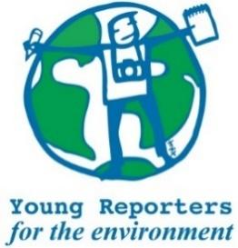

**YRE International Competition**

**Competition entry form 2025/2026**

**Category: One Take Photo**

*Questions marked with * must be answered.*

|  |  |
| --- | --- |
| **Name of student(s)\*** |  |
| **Age(s) of students as of National Competition deadline\*** |  |
| **Name of school\*** |  |
| **Town and Postcode of school\*** |  |
| **Title of the submission (within 140 characters)\*** |  |
|  |  |
| **What is the title?** |  |
| **Is the title within the limit of max. 140 characters?\*** | ☐ Yes / ☐ No |
| **Does the photo have a description of max. 100 words and a caption of max. 20 words? OR only a description of max. 120 words?\*** | ☐ Yes / ☐ No |
| **Please copy your caption (if you have one) and your description in the box to the right.** |  |
| **Please your description in the box to the right.\*** |  |
| **Is the photo a fair and truthful representation of reality and the subject and/or scene has not been manipulated or altered?\*** | ☐ Yes / ☐ No |
| **Does the description/caption include relevant and feasible solutions to the environmental issue presented in the photo?\*** | ☐ Yes / ☐ No |
| **Are the sources used in the description and/or caption cited in footnotes or** [**MLA style**](https://subjects.library.manchester.ac.uk/referencing-new/mla)**?\*** | ☐ Yes / ☐ No |
| **Was the original photo attached separately digitally as .jpeg or .png format with a resolution of** [**not less than 150-300 dpi**](https://dpi.tools/image-dpi-checker)**?\*** | ☐ Yes / ☐ No |
| **Where has the submission been disseminated?\*** | ☐ Personal Sphere (through social media such as Instagram, Twitter, YouTube, or a personal blog)  ☐ School Community (through the school newspaper, website, or as a poster or flyer in the school building.)  ☐ Eco-Schools NI (through the organisation's website or social media channels)  ☐ National Media (through newspaper, TV, radio)  ☐ Other |
| **Please attach or list evidence of dissemination (links and/or photos) that show where your submission was shared with others.\*** |  |
| **Student(s)' explanation of how the submission addresses the link between the topic and the chosen Goal(s)\***  **You can read about the SDGs here: https://sdgs.un.org/goals** |  |