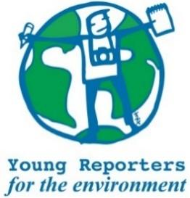**YRE International Competition**

**Competition entry form 2025/2026**

**Category: Article**

|  |  |
| --- | --- |
| **Age Group\*** | ☐ 11-14 years  ☐ 15-18 years  ☐ 19-25 years |
| **Country of residence\*** |  |
| **Name of student(s)\*** |  |
| **Age(s) of students as of National Competition deadline (24/4/2026)\*** |  |
| **Name of school\*** |  |
| **Town and Postcode of school\*** |  |
| **Title of the submission (max. 140 characters)\*** |  |
|  |  |
| **Is the submission focused on a pertinent (real and current) local issue?\*** | ☐ Yes / ☐ No |
| **Does the submission include relevant, feasible, and constructive solutions to the environmental issues presented?\*** | ☐ Yes / ☐ No |
| **Does the submission meet the limitation of word length max. 1000 words?\*** | ☐ Yes / ☐ No |
| **Please copy the title of the article in the box to the right.** |  |
| **Is the title within 140 characters?\*** | ☐ Yes / ☐ No |
| **Are the sources used in the article cited in footnotes or** [**MLA style**](https://subjects.library.manchester.ac.uk/referencing-new/mla)**?\*** | ☐ Yes / ☐ No |
| **Does the article include 1-3 photos/infographics with sources and captions of max. 20 words for each?\*** | ☐ Yes / ☐ No |
| **Please copy the captions for each photo in the box to the right.** |  |
| **Are the photos attached separately from the article as .JPEG or .PNG files?\*** | ☐ Yes / ☐ No |
| **Where has the submission been disseminated?\*** | ☐ Personal Sphere (through social media such as Instagram, Twitter, YouTube, or a personal blog)  ☐ School Community (through the school newspaper, website, or as a poster or flyer in the school building.)  ☐ Eco-Schools NI (through the organisation's website or social media channels)  ☐ National Media (through newspaper, TV, radio)  ☐ Other |
| **Please include links or photos as evidence of dissemination (links and/or photos) that show where your submission was shared with others.\*** |  |
| **Student’s brief explanation of how the submission topic is linked to at least one of the UN Sustainable Development Goals\***  **You can read about the SDGs here: https://sdgs.un.org/goals** |  |