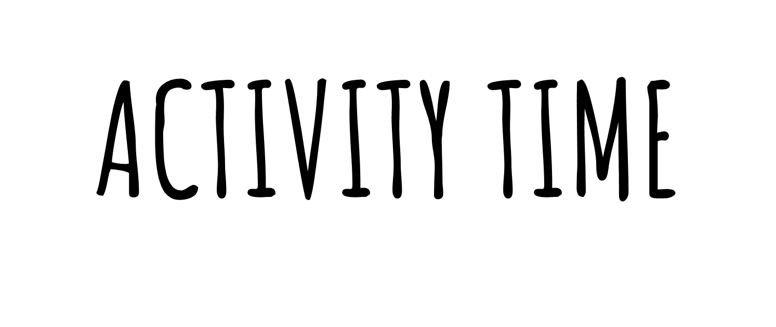

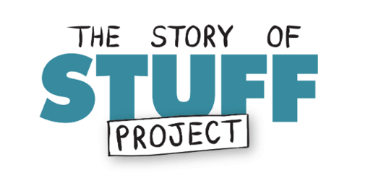
Show the video about The Story of Stuff and ask your students to prepare a list of all the unused clothes, accessories and electronic gadgets they have and they could live without
https://www.storyofstuff.org/

Could your students take the pledge to live for a week without one of the electronic garments?
Could your students take the pledge to live for a week wearing the same 2 or 3 jumpers?
Why not writing about this experience or film it as a reportage/documentary?
The final work could enter the YRE Competition – find out more at https://www.eco-schoolsni.org/cgi-bin/generic?instanceID=46

