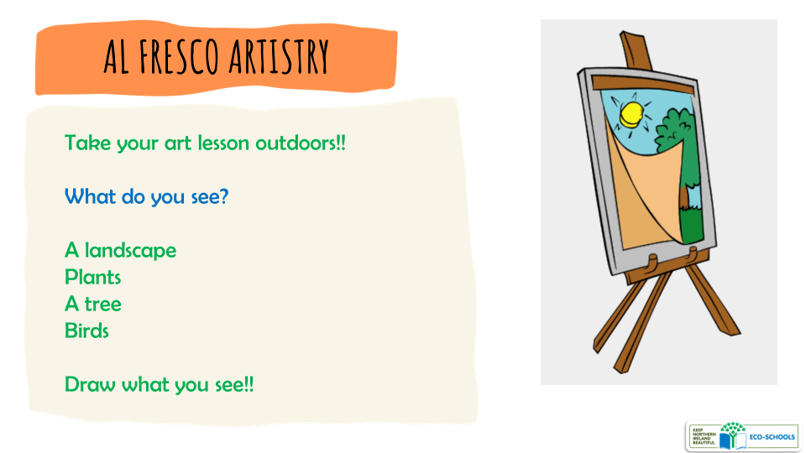

AL FRESCO ARTISTRY
There are several benefits for young children when being creative and doing art.
It promotes self-expression, confidence, creativity, accountability, attention to detail and the ability to accept feedback and criticism. And there is nothing prouder than seeing one’s work adorning the classroom walls.
If weather permits, why bother confining your class to the indoors when it’s art time? Combine the benefits of art with the health effects of the outdoors.
Challenge your learners to find something they find interesting - it might be a whole landscape, a simple plant, or perhaps a tree.

