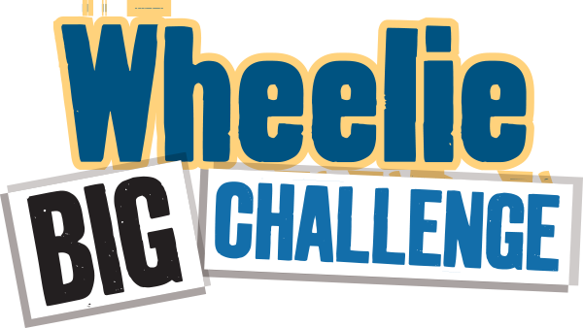
Worksheet - Waste Audit 2
Simple Audit - What’s happening outside? Has anything changed from Audit 1?
Investigate the bins outside being used by the school now. Has anything changed since Waste Audit 1?
How many bins and of what type do you have collected from the school?
(Just count the school’s bins – the canteen bins are usually on a different contract)
 | Waste/Landfill bins | Recycling Bins | Brown/food bins
Size
How many

Bin Size Guide
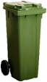  140 litre bin  (standard household bin) | 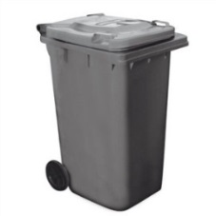  240 litre bin  (standard household bin) | 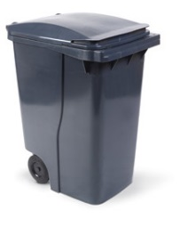  360 litre bin  (deeper than standard household bin) | 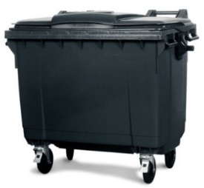  660 litre bin  (midsize - 4 wheels) | 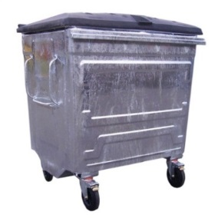  1100 litre bin  (large commercial size bin, metal or plastic)

Take a sneak peek.
What’s in the waste/landfill bins? Can you see recyclable items in there? List any that you see:
__________________________________________________________________________________
__________________________________________________________________________________
Is this an improvement from Audit 1?
__________________________________________________________________________________

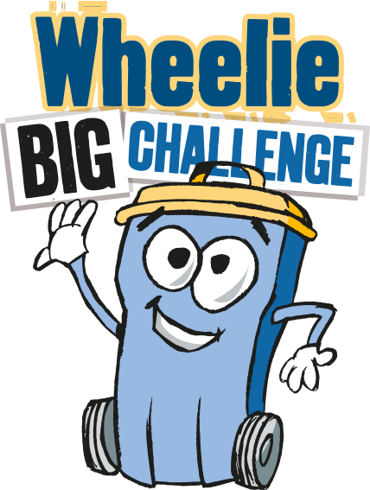
Detailed Audit - What’s happening inside the school?
The aim of this task is find out what is in your waste bins that could be recycled. We are not weighing recycling bins for this task – although you may want to do that separately. You will need gloves, scales and perhaps a plastic sheet for this activity.

Choose 5 small waste bins from a variety of areas (eg. classrooms, office, ITC room, staff room) towards the end of the day. Note you will audit the same bins as you did for Audit 1. Tip them out, separately, one at a time, onto a floor space that is easy to sweep/clean up – perhaps a plastic sheet would help.
Wearing gloves sort out the rubbish from each bin and using the scales weigh (in grams) each type you find in the table below.

 | Mixed Dry Recyclables  (eg. paper, card, plastic, yoghurt pots, tins) / grams | Compostable Food  (e.g. crusts, fruit, teabags)  / grams | Non-Recyclable  (e.g. wrappers, cling film, pens, straws, tissues)  / grams | Overall weight  (eg. everything in the bin)  / grams
Bin 1 from:

Bin 2 from:

Bin 3 from:

Bin 4 from:

Bin 5 from:

Total weight
Percentage | _________% | _________% | _________% | 100%

Has there been an improvement from waste Audit 1? Dry Recycling % improvement ____________ Food Recycling % improvement ____________

