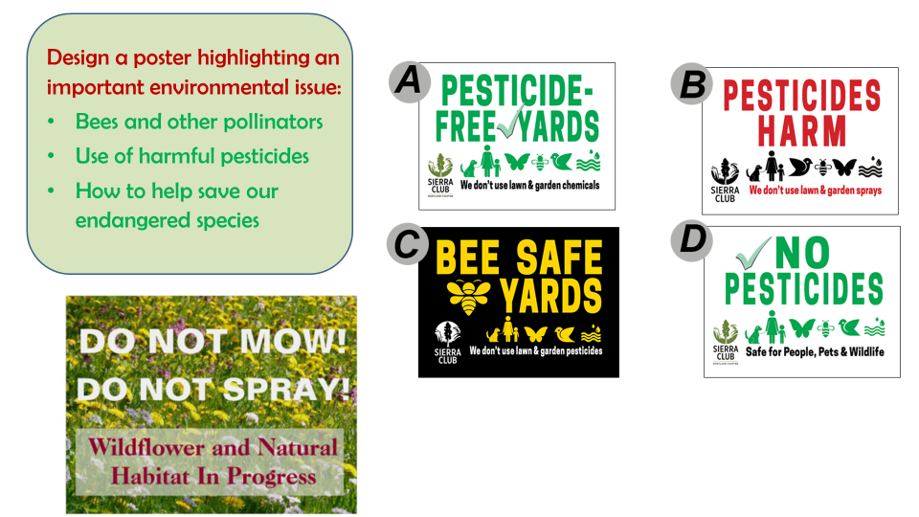
Write down some key information you would like to include in your poster.

