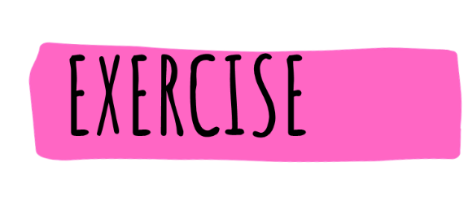

Discuss with your students some concepts about waste and laws for waste management

Divide the class into groups of 3-4 students
Ask your students to undertake an internet-based research on different types of laws and legislations linked to waste (give a week)
Assign to different groups different aspects so to have a discussion in class on another day
- Laws about categories of waste
- Laws about collection of waste
- Laws about disposing of waste – how and where
- Laws about behaviours (dog fouling; littering; fly-tipping and illegal waste dumping)

Write an article or prepare a presentation about your findings

Ask the groups to prepare a presentation or to write an article, just like a real reporter, about their findings.
Each group will present each week in front of the classroom informing the rest of the groups about their research and the key points of their work
They will also propose solutions to the issue
The rest of the classroom is invited to an open discussion about the topic presented

Why not submitting your article to the YRE Competition?
https://www.eco-schoolsni.org/cgi-bin/generic?instanceID=46

