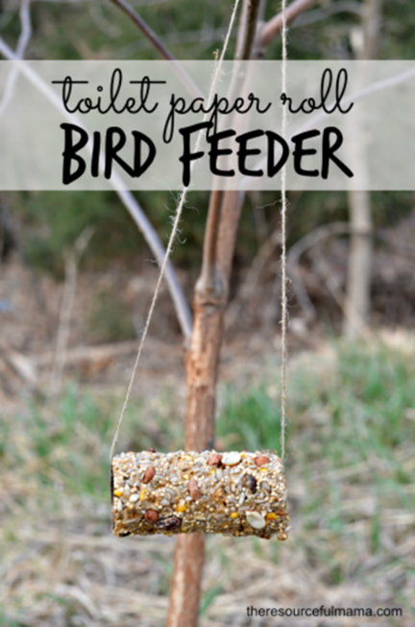
EASY TOILET PAPER ROLL BIRD FEEDER CRAFT
When is a recycled product better than the original? When it's turns into a bird feeder.
Enjoying the outdoors can happen in the garden, and lots of garden birds will pay you a visit with this recycled bird feeder

