Eco-Schools Data Collection Form

As part of the Green Flag award process, schools are expected to supply some quantifiable data in relation to the topics they have covered. This form is designed to help with Monitoring and Evaluation which traditionally has been a step that most schools have found difficult. By collecting data, the aim is to help schools to see the real impact of their work. Through collecting and monitoring data it will ultimately help schools with the evaluation part of the step i.e. to consider the results achieved - are these as expected, if not why not?; identify any areas for improvement; and to celebrate any areas of success.

The main thing is that we are not looking for perfect results and there may be times where the data is not as expected – schools can explain why on the form. We strongly recommend that schools review this form at the start of the application process and complete them as they go along. While the form may look daunting it is really a tool to support monitoring just for the 3 topics which the school is studying. We hope the results will provide Eco-Schools with some standardised data about the overall impact of the Programme in Northern Ireland which we would like to share with schools.

Guidance Notes for Completion of the Form
Please complete the tables below only for the topics which your school has studied and submit 3 copies of the forms with your Green Flag Application. If your school has additional monitoring and evaluation details we would like to see these also so please feel free to submit any additional information with your application as well (one copy of any additional information is sufficient).

It is important that you compare data for two similar periods i.e. if the figures you are providing for last year were taken in winter months, then provide figures taken from winter months in the current year as well.

Please note that if you are applying for your Green Flag this year and have no comparative data, please still supply data for the current year.


□ Litter Topic

 | Start Date for period over which litter collection was monitored | Finish Date for period over which litter collection was monitored | No. of Clean-Ups | No. of Bags of Rubbish Collected | Weight of Bags of Rubbish Collected  (avg bag of rubbish weighs 6.6kg) | No. of People involved in Clean-Ups | Please tick to add your Results to the BIG Spring Clean Total*
Previous Year
Current Year

*The BIG Spring Clean is Northern Ireland’s Biggest Clean-Up. By adding your results to the BIG Spring Clean this will help give a better picture of how Eco-Schools are also involved in clean-ups, whether it is a quick break-time litter pick of the playground or a bigger clean-up of the local area it all adds up. We will also send you a BIG Spring Clean kit to use to keep up the good work, if your school has not already registered. (Kit contains: information on how to organise a clean-up, 20 refuse bags, a high visibility vest for the group coordinator and children’s stickers; and a BIG Spring Clean Certificate of Participation).

Any comments:
□ Waste Topic (Resource Efficiency)

Please provide figures for all types of waste produced by your school – general, recycling, compost, etc. for two similar periods i.e. if the figures you are providing for last year were taken in winter months, then provide figures taken from winter months in the current year as well.

If you are counting your waste in bins/bags please note the size of the bins/bags used in the school:
 |  | Start date for period over which Waste consumption was calculated | Finish date for period over which Waste consumption was calculated | No. of school days in this period | Amount of Waste  (kg/bags/bins - 120l/240l/1110l etc.) | Cost  (£) | How did you measure your Waste consumption?
Previous Year | General Waste  
 | Recycling
Composting
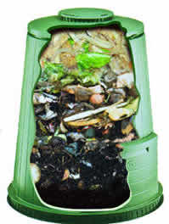
Current Year | General Waste
 | Recycling
 | Composting

Any comments:
□ Energy Topic

Please compare energy consumption for two similar periods i.e. if the figures you are providing for last year were taken in winter months, then provide figures taken from winter months in the current year as well. Your school bursar or local Energy Officer at your Education and Library Board may be able to assist you with the figures for the amount of energy used.

 | Type – complete for each type used in your school | Start date for period over which energy consumption was calculated | Finish date for period over which energy consumption was calculated | No. of school days in this period | Amount of energy used in kWh/Litres, etc. | Average amount of energy used per person per day * | Cost  (£) | How did you measure your energy consumption?
Previous Year | Electricity
 | Oil
Other

_________
Current Year | Electricity
 | Oil
Other

_________
- This is calculated by dividing the amount of energy used by the average number of persons in the school.

If you have experienced an increase in energy consumption, please outline the reasons:

□ Increase in school electrical equipment/appliances (e.g. interactive whiteboards)
□Increase in school population/building size
□Other, please specify _______________________________________________

Please provide a copy of your Display Energy Certificate (DEC), if applicable.

Any comments:


□ Water Topic
Please provide figures for the amounts of water your school used for two similar periods i.e. if the figures you are providing for last year were taken in winter months, then provide figures taken from winter months in the current year as well.

Please compare the amounts of water your school used for two periods over the duration of your Water topic.

 | Start date for period over which water consumption was calculated | Finish date for period over which water consumption was calculated | No. of school days in this period | Amount of water used in litres  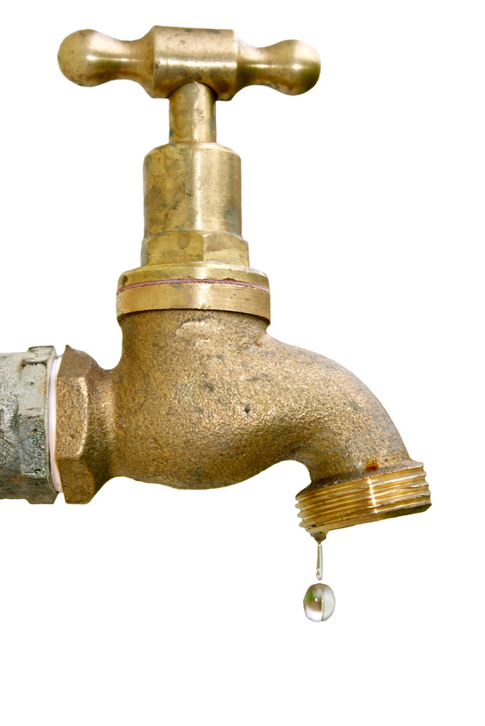 | Average No. of litres used per person per day * | How did you measure your water consumption?
Previous Year
Current Year
- This is calculated by dividing the amount of water used by the average number of persons in the school.

If you have experienced an increase in water consumption, please outline the reasons:

□ Leak
□Increase in school population/building size
□ Other, please specify _______________________________________________

Any comments:
□ Transport Topic

Please compare the types of journeys by different travel modes to school for two periods over the duration of your transport topic i.e. at the beginning and the end.

School Travel Survey (total for all staff and students)
 | Survey 1 – Date ___________ | Survey 2 – Date ____________
No. of Journeys
Walk
Cycle
Park n’ stride
Bus/train
Carpool
Car
Distance Travelled (Miles travelled to school)
By petrol car miles per year
By diesel car miles per year
By bus miles per year
By train miles per year
By bike/foot miles per year

If you have taken part in any sustainable travel initiatives e.g. walk to school week or cycle to school week please outline details below.
Type of Day | No. of Days Held | No. of Participants
Walk to School
Cycle to School
Other ____________________________

If you have experienced no change or an increase in car journeys, please outline the reasons.

□Increase in school population/building size
□ Change in school location
□Other, please specify _______________________________________________

Any comments:
□ Climate Change Topic

We can estimate the average production of carbon dioxide over time by a school through looking at energy consumption (electricity, oil, etc.), waste production (both for landfill and recyclables), travel (miles travelled by bus, car etc.), and water consumption. A carbon calculator will use conversion factors to convert the recorded values - be it for energy, waste, travel or water - into a final figure for CO2 emissions. By calculating this figure, it should then be easier to try to make changes, specifically in the areas mentioned, in order to reduce the impact the school may be having on climate change.

To evaluate and measure progress made in the climate change topic please complete the sections below at the beginning of your work on the climate change topic before any actions were implemented and results obtained near the end of your of work on the climate change topic.
Audit 1 Audit 2
Date __________ Date __________
Litter & Waste
1. Waste going to landfill kg/year x 1.5 (conversion factor) = kgCO2 = kgCO2
2. Waste for recycling __ ________ kg/year x 0.3 (conversion factor) = kgCO2 = kgCO2
3. Compost (carbon neutral) _____ kg / year x 0 (carbon neutral) = kgCO2 = kgCO2
Total CO₂ emissions from Waste = kgCO2/year = kgCO2/year
-------------------------------------------------------------------------------------------------------------------------------
Energy
1. Electricity (Kilowatt-hours) kWh / year x 0.6 = kgCO2 = kgCO2
2. Natural Gas (Kilowatt-hours) kWh / year x 0.19 = kgCO2 or = kgCO2
3. Natural Gas (therms) therms / year x 5.5 = kgCO2 = kgCO2
4. Oil (litres) ________litres / year x 2.69 = kgCO2 = kgCO2
Total CO₂ emissions from energy consumption = kgCO2/year = kgCO2/year
--------------------------------------------------------------------------------------------------------------------------------
Transport (total for all staff and students)
1. Miles travelled by petrol car miles/year x 0.36 = kgCO₂ = kgCO₂
2. Miles travelled by diesel car miles/year x 0.28 = kgCO₂ = kgCO₂
3. Miles travelled by bus miles/year x 0.03 = kgCO₂ = kgCO₂
4. Miles travelled by train miles/year x 0.1 = kgCO₂ = kgCO₂
5. Miles travelled by bike/foot miles/year x 0 = kgCO₂ = kgCO₂
Total CO₂ emissions from transport to and from school = kgCO₂/year = kgCO₂/year ---------------------------------------------------------------------------------------------------------------------------------
Water
1. Total water consumption _____ litres / year x 0.001 = ________ kgCO₂/year = ________ kgCO₂/year ---------------------------------------------------------------------------------------------------------------------------------
TOTAL CO₂ PRODUCTION PER YEAR = Sum of above totals = kgCO₂/year = kgCO₂/year
Total CO₂ / number of staff & students = ____ kgCO₂ /person /year = ____ kgCO₂ /person/year
Total CO₂ / m² of school building(s) = kgCO₂ / m² / year = ____ kgCO₂ / m² / year


□ Biodiversity Topic
Please compare the results of your Biodiversity Awareness Survey (i.e. results obtained at the beginning of your work on the Biodiversity topic before any actions were implemented and results obtained near the end of your of work on the Biodiversity topic)

 | Survey 1 – Date ___________ | Survey 2 – Date ____________
What % of students and staff knew what the term biodiversity meant?

What % of students and staff were able to list 3 reasons why biodiversity is so important?

What % of students and staff were able to list 3 threats to biodiversity?

What % of students and staff were able to list 3 ways in which we can help biodiversity?

To show progress made in the Biodiversity topic you could also prepare a before and after map/photo of the school grounds showing the various habitats and species found in your school grounds.

□ Healthy Living Topic
To evaluate and measure progress made in the healthy living topic you could complete a school survey to assess the eating and exercise habits before and after and prepare a chart to show improvements.


□ School Grounds Topic
To evaluate and measure progress made in the school grounds topic you could complete a school survey to get opinions before and after e.g. percentage of school who thought the school grounds could improve, etc. and prepare a before and after map/photo of the school grounds showing the various improvements.


□ Global Perspectives Topic
To evaluate and measure progress made in the global perspectives topic you could complete a school survey to assess knowledge before and after and prepare a map showing the global links with your school e.g. where our food comes from, other countries we have learned about, etc.

