Eco- Review

For Nursery Schools

Eco-Schools Northern Ireland would like to acknowledge Downpatrick Nursery School for their invaluable input in the design of the Eco-Schools Nursery School Environmental Review.

******C:\Users\joanne.mcdonnell\AppData\Local\Microsoft\Windows\Temporary Internet Files\Content.IE5\QRGICEL2\MC900446144[1].wmfEnergy**

What is the weather outside?

**Doors**

Is the sliding door closed?

Is the door to the main hallway closed?

Is the door to the back hallway closed?

Is the main door closed?

**Windows**

Are all the playroom windows closed?

Are the bathroom windows closed?

Are the windows in the quiet room closed?

**Energy**

Are there any lights on?



Playroom

Quiet room

Bathroom

Office

Main hallway

Back hallway

Back store

Kitchen

**Healthy living**

What do we have for snack?

Draw pictures of what you like…..

To drink? To eat?

How do we ‘exercise’ in school?

      

 

How many plants do we have inside school?

 

1 2 3 4 5 6 7 8 9 10+

**Litter**

Are there any pieces of litter outside in the garden?

Yes No

If yes, how many pieces of litter are there?



How many bins are there inside school?



1 2 3 4 5 6 7 8 9 10

C:\Users\joanne.mcdonnell\AppData\Local\Microsoft\Windows\Temporary Internet Files\Content.IE5\674Q0D3W\MC900250897[1].wmf**Recycling**

What do we recycle?

No Yes



Paper



Plastic bottles

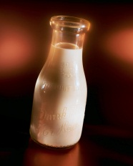

Glass



Food Waste

Look and see…………………………

(photographs to be taken of the children at each location they can think of)

**Biodiversity and School grounds**



What can you see outside?

Flowers

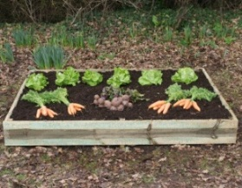

Vegetable beds

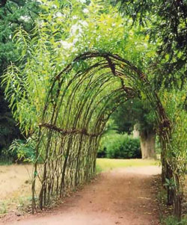

Willow Tunnel

[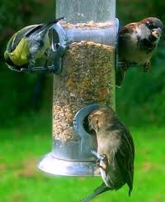](http://www.google.co.uk/imgres?um=1&hl=en&sa=N&biw=1366&bih=616&tbm=isch&tbnid=MhqanAQHy-9mbM:&imgrefurl=http://www.greenfootsteps.com/wild-bird-feeder.html&docid=EL4cqF5WxqSV5M&imgurl=http://www.greenfootsteps.com/images/3birds-sept07.jpg&w=250&h=305&ei=WhMyUI23MKKZ0QX_4YHoDA&zoom=1&iact=hc&vpx=794&vpy=112&dur=9090&hovh=244&hovw=200&tx=99&ty=159&sig=116491059800186185967&page=1&tbnh=137&tbnw=122&start=0&ndsp=23&ved=1t:429,r:13,s:0,i:113)

Birds

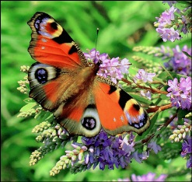

Butterflies

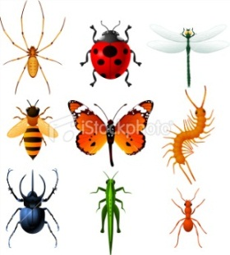

Bees/Insects

**Transport**

How do you come to school?

Walking



By bus



By car

Symbols for the children to use to make pictogram

     

  

    

**Water**

How many taps are in school?



1 2 3 4 5 6 7 8 9 10 11 12 13 14



15 16 17 18 19 20+

Are any left running?

Yes No

Are there any taps dripping?

None dripping  Some dripping 

 

**Global Perspective**

Do you learn about boys and girls from poor countries?

Yes No



Do they always have clean

drinking water?

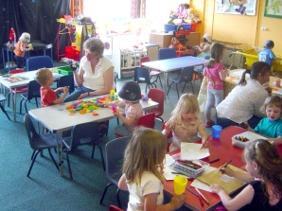

Do they always go to

school?

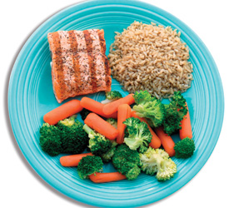

Do they always have

enough food?

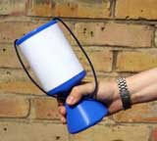

Does your school give money

to help others?

**Climate Change**



Do you learn about the Earth and how to keep it healthy?

Yes No

What do you do? 

[](http://www.google.co.uk/imgres?hl=en&biw=1366&bih=616&tbm=isch&tbnid=_tZtiUgGoVN7CM:&imgrefurl=http://www.dreamstime.com/royalty-free-stock-photos-earth-cartoon-mascot-switch-off-image13786858&docid=G5l5CCDcDkZNCM&imgurl=http://www.dreamstime.com/earth-cartoon-mascot-switch-off-thumb13786858.jpg&w=400&h=390&ei=ZiQyUILZMcbP0QXq5YDoDA&zoom=1&iact=hc&vpx=280&vpy=275&dur=14&hovh=222&hovw=227&tx=134&ty=168&sig=116491059800186185967&page=1&tbnh=118&tbnw=121&start=0&ndsp=27&ved=1t:429,r:20,s:0,i:159)

Switch off lights and televisions



Walk to school/shops

[](http://www.google.co.uk/imgres?hl=en&biw=1366&bih=616&tbm=isch&tbnid=Cq5b1wckZIAz3M:&imgrefurl=http://wakeup-world.com/2011/09/15/10-great-reasons-to-eat-local-food-where-you-can-pick-your-own/&docid=fq6K72qWkpkNTM&imgurl=http://wakeup-world.com/wp-content/uploads/2011/09/Eat-Local.jpg&w=1000&h=883&ei=mCUyUIeiOMTI0QXZ9IHYDA&zoom=1&iact=hc&vpx=115&vpy=139&dur=1420&hovh=211&hovw=239&tx=123&ty=120&sig=116491059800186185967&page=1&tbnh=135&tbnw=153&start=0&ndsp=21&ved=1t:429,r:0,s:0,i:70)

Buy food grown locally

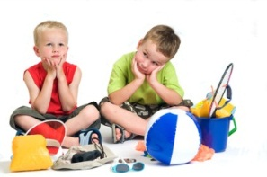

Holiday at home

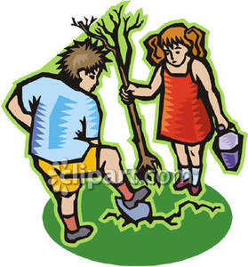

Plant trees